AI DOCTOR: INTELLIGENT DISEASE PREDICTION SYSTEM

1. ABSTRACT
This project presents an intelligent disease prediction system powered by machine learning and implemented as a full-stack web application. The system enables users to input symptoms through an interactive interface, after which a trained machine learning model analyzes the input and predicts the most probable disease along with a confidence score.
The primary aim of this system is to support early-stage health awareness by providing users with a preliminary analysis of their symptoms. While it does not replace professional medical consultation, it serves as an assistive tool that demonstrates how artificial intelligence can be applied in healthcare decision support systems.

2. INTRODUCTION
Healthcare systems across the world face challenges related to accessibility, efficiency, and early diagnosis. In many situations, individuals are unable to access immediate medical consultation, leading to delays in identifying potential health conditions.
Artificial Intelligence (AI) and Machine Learning (ML) have emerged as powerful technologies capable of analyzing large datasets and identifying patterns that are not easily observable by humans. In the medical domain, these technologies can be used to build predictive systems that assist in early disease identification based on symptoms.
This project focuses on developing a disease prediction system that uses machine learning techniques to analyze user-provided symptoms and generate possible disease outcomes. The system is implemented as a full-stack application consisting of a React-based frontend, a Flask backend, and a machine learning model trained on a structured medical dataset.

3. PROBLEM STATEMENT
In traditional healthcare systems, patients often rely on manual consultation with doctors, which may involve waiting times, limited availability, and accessibility issues. Additionally, individuals may lack the knowledge to interpret symptoms accurately, leading to delayed or incorrect self-assessment.
There is therefore a need for a system that can provide quick and automated preliminary analysis of symptoms. Such a system should be capable of processing user input efficiently and generating meaningful predictions that can guide users toward seeking appropriate medical attention.

4. OBJECTIVES
The primary objective of this project is to design and implement an AI-based system capable of predicting diseases based on user-input symptoms. The system also aims to create a user-friendly interface that allows non-technical users to interact easily with the model.
Another important objective is to integrate machine learning with web technologies, demonstrating how predictive models can be deployed in real-world applications through APIs and interactive interfaces.

5. TECHNOLOGY STACK
The system is developed using modern web and machine learning technologies:

Frontend:
- React.js (for UI development)
- CSS (for styling chat interface)

Backend:
- Flask (Python web framework)
- Flask-CORS (for cross-origin communication)

Machine Learning:
- Scikit-learn
- Random Forest Classifier

Dataset:
- Kaggle Symptom-Disease Dataset (structured binary symptom data)

6. SYSTEM ARCHITECTURE
The architecture of the system follows a modular client-server design. The user interacts with the frontend interface, where symptoms are entered in a chat-like format. These inputs are then sent to the backend Flask server through API requests.
The backend processes the input and forwards it to the trained machine learning model. The model analyzes the symptom patterns and generates a prediction, which is then returned to the frontend. Finally, the result is displayed to the user in a readable format along with a confidence score.
This separation of frontend, backend, and model ensures scalability and maintainability of the system.

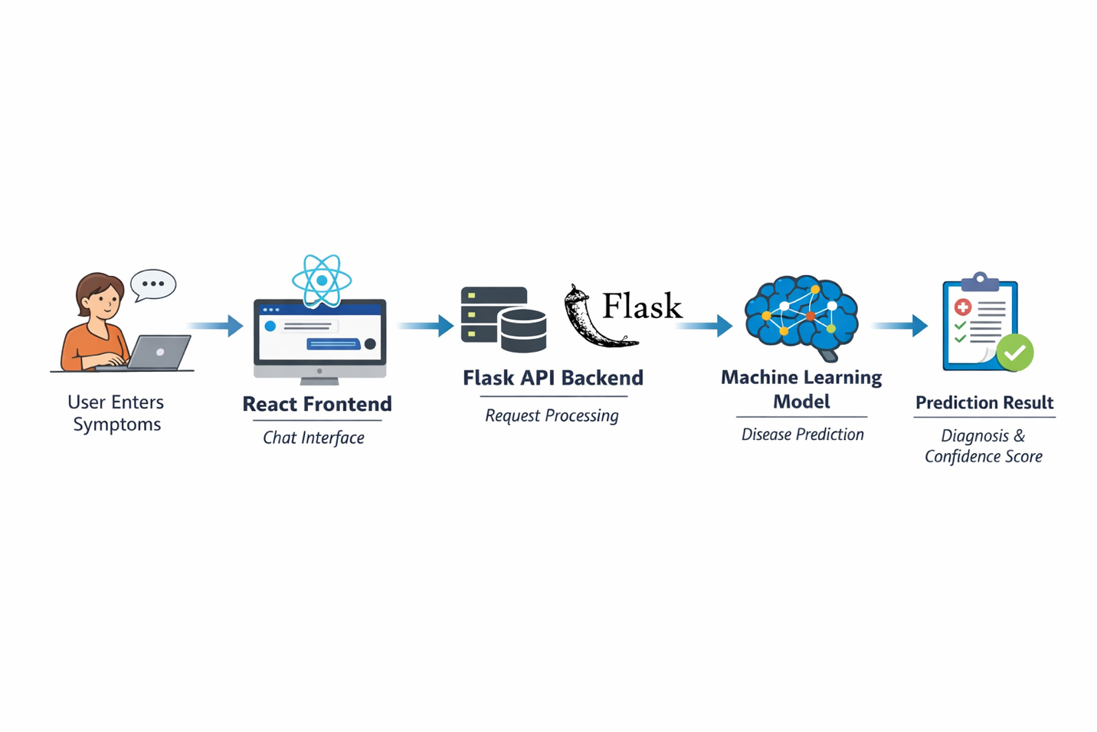

7. METHODOLOGY
The system development process consists of the following stages:

7.1 Data Collection
A structured dataset containing symptoms and corresponding diseases was obtained from Kaggle. Each symptom is represented as a binary feature (0 or 1).

7.2 Data Preprocessing
- Handling missing values
- Encoding symptom features
- Splitting dataset into training and testing sets

7.3 Model Training
A Random Forest Classifier was used due to its high accuracy and ability to handle high-dimensional data.

7.4 Model Evaluation
The model was evaluated using accuracy score and cross-validation techniques.

7.5 System Integration
The trained model was integrated into a Flask API, which communicates with the React frontend.

8. RESULTS AND DISCUSSION
The implemented system successfully predicts diseases based on user-input symptoms. The model demonstrates high accuracy, which is attributed to the structured nature of the dataset and the effectiveness of the Random Forest algorithm.
The system is capable of generating predictions in real time and also provides a confidence score indicating the reliability of the prediction. The chat-based interface enhances user experience by making the system interactive and easy to use.
However, it is important to note that the system operates as a preliminary diagnostic tool and should not be considered a replacement for professional medical consultation.

9. LIMITATIONS
Although the system performs well on structured datasets, it has certain limitations. The model relies heavily on predefined symptom-disease mappings, which may not fully represent real-world medical complexity. Additionally, the system does not currently handle unstructured or ambiguous user input effectively.
Another limitation is that medical conditions often involve multiple overlapping symptoms, which may not always be accurately captured by the dataset used.

10. FUTURE SCOPE
The system can be enhanced in several ways to improve its performance and usability. Natural Language Processing techniques can be integrated to allow the system to understand complex and conversational user inputs. Voice-based input functionality can also be added to improve accessibility.
Furthermore, deploying the system on cloud platforms would make it accessible to a wider audience. The use of more diverse and real-world medical datasets would significantly improve model generalization and reliability.

11. CONCLUSION
This project demonstrates the application of artificial intelligence in healthcare through a disease prediction system that combines machine learning with modern web technologies. The system provides users with a fast and interactive way to analyze symptoms and obtain preliminary disease predictions.
Although it is not intended for clinical diagnosis, it effectively showcases how AI can support healthcare systems by providing early insights and improving accessibility to medical information.

